8.9.22

Dear Parents and Carers,

We are three weeks into the new term and the buzz in school is incredible. We are so pleased to have everyone back and enthusiastic for the year ahead.

Welcome Back!
Mrs Youngman, Mrs McKenzie and Mrs Chisholm have returned from maternity leave and we look forward to welcoming Mrs Power back after the October break. Mrs Sutherland has returned from a secondment with the early Years Team. We are so happy to have them back in school.

Pupil Leadership Roles:
Thank you to the pupils in p6 and p7 who have applied for leadership roles. Interviews will take place on Thursday 15th September. As you can imagine the standards are really high and it is going to be a very tricky task. I need to emphasis that in interview, as in life, not everyone can be a winner, this is a very important part of developing resilience and learning about life and work. We will have clear criteria, will be rigidly fair and our decision on the day will be final.

Health Week:
Mrs Clark and her class have arranged a week full of activities for the week beginning 19th September. We are excited to be having a Health and Wellbeing Week at Macduff Primary from 19-23/9/22. Pupils in P1-7 will be trying a range of activities, from Street Dance to rugby, during this week, led by groups from the community. Classes will have the Scarf wellbeing tent and visits from the local community police. We even have a smoothie bike coming!! All arranged activities will be to promote health and wellbeing in our pupils.

Clothing:
The weather has been as changeable as ever, yesterday I thought Noah might appear with his ark at any moment and then the sun came out. It is important that everyone brings a labelled outdoor coat every day ready for whatever nature throws at us. Please also put some spare clothing in for wet weather in case we get caught in a downpour and need to change!

Lunches:
Due to allergies in school, please avoid nuts in packed lunches. To avoid choking please also cut grapes in half if you are providing them.
Our lunches are prepared in school and there is a lovely range of options. P1 – P5 are entitled to lunch for free.
It is wonderful to see everyone coming with their reusable water bottles. Please remember we only allow water for classroom drinks, please do not put in juice.

Tuck Shop:
Tuck shop is available daily at playtime. Prices start at 10p and go up to 60p. We sell raisins, fruit, cheese, yoghurt, water and flavoured water.

Social Media:
We love your kind comments and encouragement on social media and we are always really keen to share what is happening in school. We don’t monitor social media regularly so if you have a question or suggestion please contact us directly at school. If you wish to join our Facebook page your request will be declined if you have not answered the security questions.
Please also remember we cannot engage in negativity on social media, so when a hard-working teacher finds her efforts criticised on TikTok it can be very distressing. Come and talk to us, we are approachable and keen to work with you.

Children on Social Media:
Under no circumstances, at any time, is it ok for your child to be on social media. Primary aged children are too young. I cannot emphasis enough the dangers of thinking everyone else is doing it so it will be fine. It really is not fine and a vast amount of time including police and social work was taken up last year due to under aged pupils on social media. My advice will always be the same when a parent contacts the school regarding an issue on social media – ‘why was your child on it in the first place?’

Carpark:
At no time should parents or children be cutting across the school carpark. This is really dangerous as cars and large catering lorries are in and out at all times of the day.

P.E.:
For safety we do not recommend wearing jewellery to school. All jewellery including earrings should be removed for P.E. If your child cannot remove their earrings, please provide tape to go over them. We would recommend always tying back long hair but for P.E. this is compulsory.

You said, we did….:
In our feedback we were asked about our reporting to parents as, due to covid, it was a little less than we would have liked last year with just the interim report initially. This year we will be reintroducing open afternoon, and class assemblies as a more interactive way of reporting to parents and sharing the children’s learning.
We have been asked to share a little more about how the children are assessed. Excellent suggestion and we will be sharing our shiny new policy with you in the coming weeks. If you wish to influence this type of thing further, we would love you to join the parent council and share your views. The next meeting is on Tuesday 13th September. Please contact the school if you would like us to share the link to the meeting with you.
Bullying was mentioned as was praise for our restorative approaches. We will work hard to get better and better at this and to empower the children to come forward if they are concerned. In the main I see a very happy school but it would be naïve to say no one is ever mean.
We can’t return to paper copies of the newsletter, our budget simply doesn’t run to the printing costs. We won’t be making the teachers more accessible to direct contact from parents. They are happy to communicate with any parent but please remember their job requires them to prepare lessons, teach the children and evaluate how that went. It is a massive task and they need their down time and family time too.

School Improvement Plan:
You have the opportunity to directly influence the school improvement plan through filling in our parental feedback form and even more directly through membership of the parent council. This year we will be focusing on:
- planning, assessment and evaluation
- developing skills in literacy
- further developing nurturing approaches
A number of our team are involved in leadership training which will include researching and leading our school improvement priorities.

Cost of Living:
https://helpforhouseholds.campaign.gov.uk/
We will share information on support as we learn about it via our Facebook page and please contact us in confidence if you would like us to direct you towards help and advice. We have some super fun plans for the winter that will help all of us as none are immune from the challenges ahead. We will be working in partnership with the church to not only tackle the cost of living as it impacts us all but find some ways to come together as a community for fun and may even a fine piece through the winter. Watch this space, and please support our initiatives as it will be a great opportunity for the children to be involved in their community.

Some Dates for your Diary:
Details to follow
13th September Parent Council on Teams 7pm
19th – 23rd September Health Week
21st September Open Afternoon 2pm -3pm
21st September Parent Support Group in school 6.30pm
15th & 16th November Parents meetings and book fair
13th, 14th & 15th December Nativity
Wk beg 19th December Parties

Kind Regards,
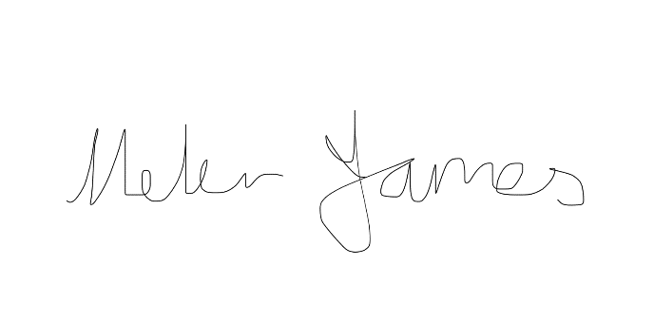
Head Teacher

